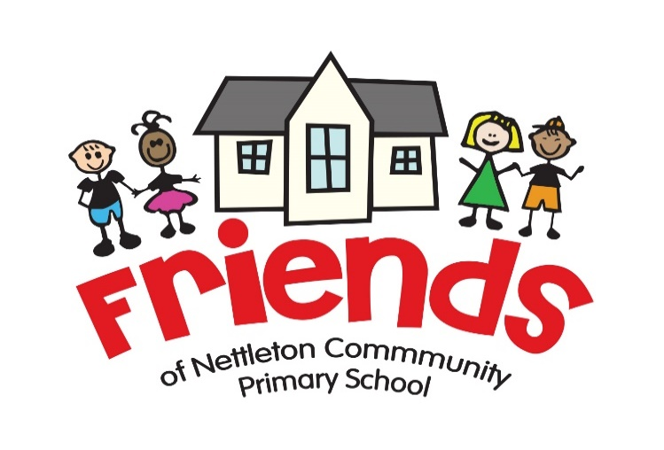

Cake Raffle Fridays!

Dear Parents/Carers,

In the past, Friends of School have run a fundraising cake raffle each Friday and we are pleased to say: it is back! Children enter by buying raffle tickets for 20p per ticket – this ticket buys them the chance to win a cake kindly donated by a parent or carer. The raffle will take place every Friday, starting this coming Friday (16th September) and all money raised will be put back into the school for the benefit of every pupil.

Friends of School will get the raffle started by donating the cakes in the first few weeks, but we need your help to ensure it is a success! We would like to ask for your support in this coming year to keep the raffle going – if you are able and would like to donate a cake please email contactfriendsofschool@googlegroups.com by Friday 30th September. Please include the following details and we will include you in our annual list, alongside a date when it is your turn. We will send this list out to you once it is complete.

Information required:

- Your name
- The name and class of your child/children

You don’t need to be Mary Berrry to get involved – a simple home bake or a pre-packaged, ‘shop bought’ cake are both equally accepted. Also, it doesn’t have to be one cake: it could be fairy cakes or chocolate rolls…anything cakey goes and we will be extremely grateful to receive it!

Thank you all in advance for your support!
Friends of School

