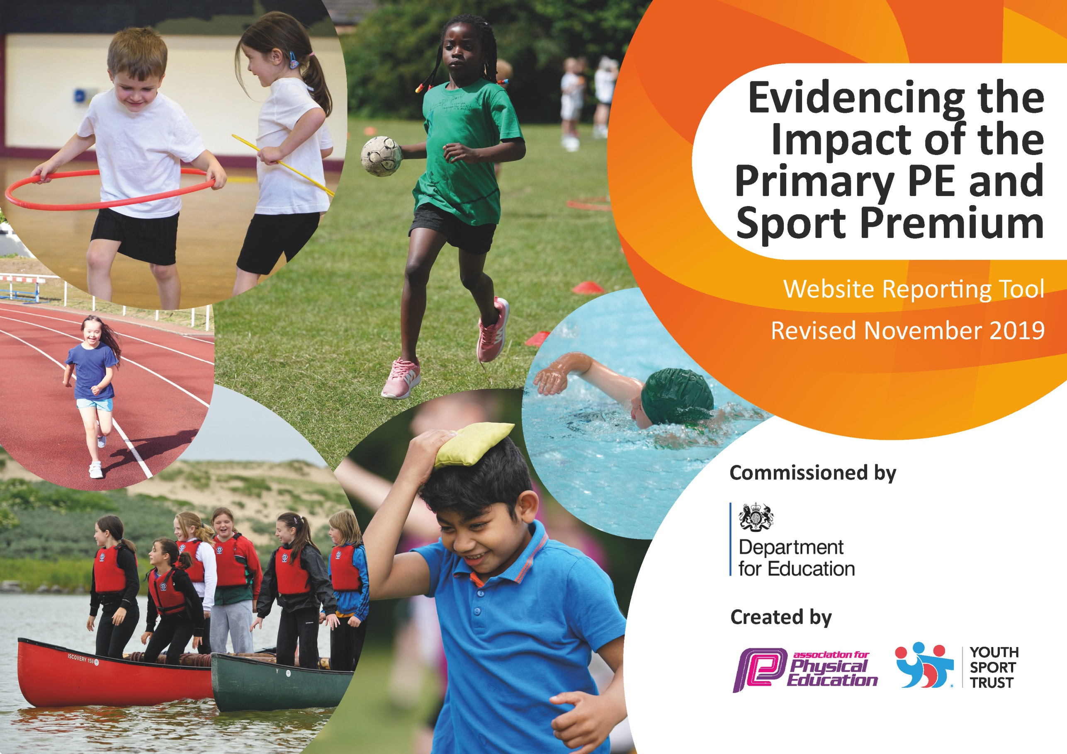
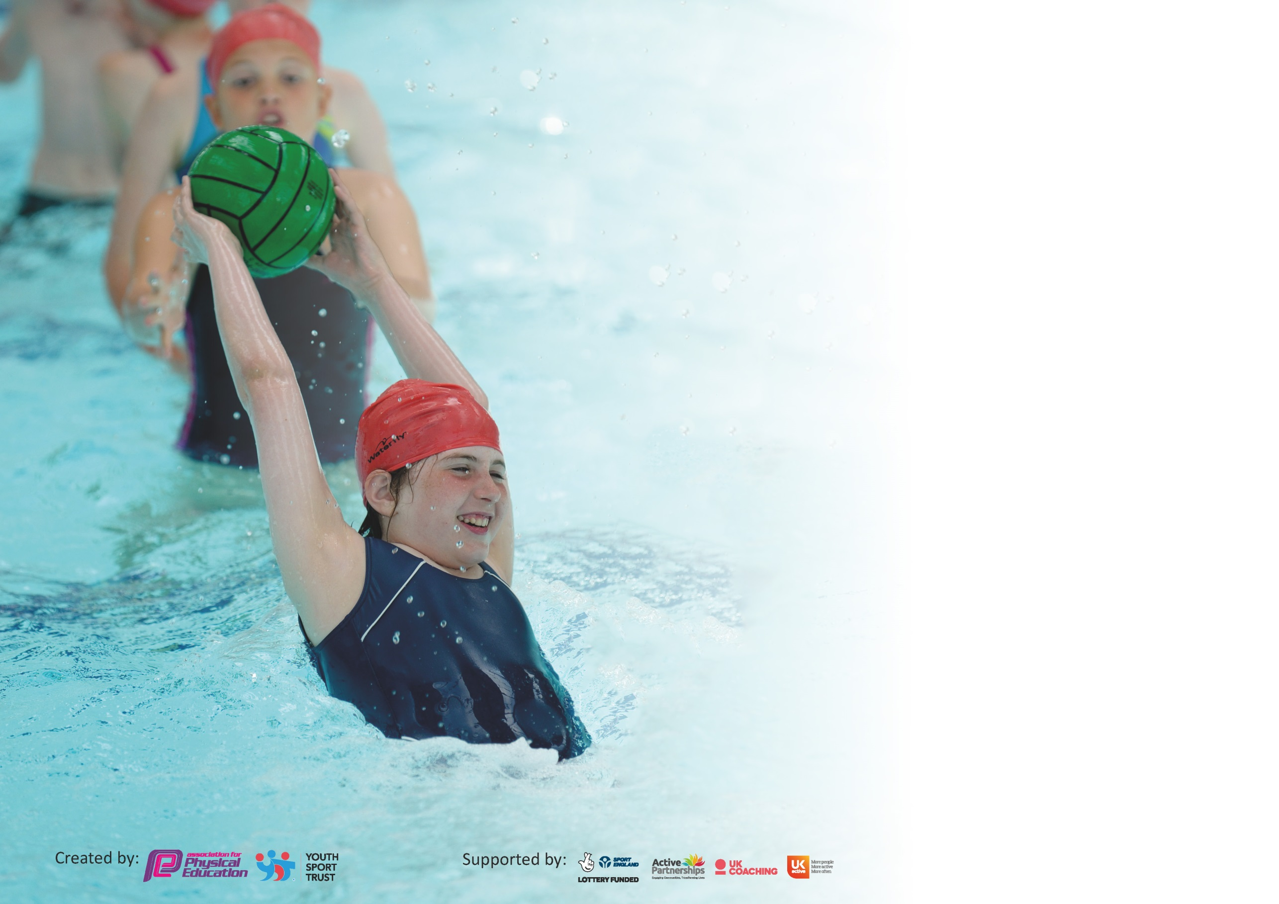

It is important that your grant is used effectively and based on school need. The Education Inspection Framework (Ofsted 2019 p64) makes clear there will be a focus on ‘whether leaders and those responsible for governors all understand their respective roles and perform these in a way that enhances the effectiveness of the school’.

Under the Quality of Education criteria (p41) inspectors consider the extent to which schools can articulate their curriculum (INTENT), construct their curriculum (IMPLEMENTATION) and demonstrate the outcomes which result (IMPACT).

To assist schools with common transferable language this template has been developed to utilise the same three headings which should make your plans easily transferable between working documents.

Schools must use the funding to make additional and sustainable improvements to the quality of Physical Education, School Sport and Physical Activity (PESSPA) they offer. This means that you should
use the Primary PE and Sport Premium to:

- Develop or add to the PESSPA activities that your school already offer
- Build capacity and capability within the school to ensure that improvements made now will benefit pupils joining the school in future years

Please visit gov.uk for the revised DfE guidance including the 5 key indicators across which schools should demonstrate an improvement. This document will help you to review your provision and to report your spend. DfE encourages schools to use this template as an effective way of meeting the reporting requirements of the Primary PE and Sport Premium.

We recommend you start by reflecting on the impact of current provision and reviewing the previous spend.

Schools are required to publish details of how they spend this funding as well as on the impact it has on pupils’ PE and sport participation and attainment by the end of the summer term or by 31st July 2020 at the latest.

We recommend regularly updating the table and publishing it on your website throughout the year. This evidences your ongoing self-evaluation of how you are using the funding to secure maximum, sustainable impact. Final copy must be posted on your website by the end of the academic year and no later than the 31st July 2020. To see an example of how to complete the table please click HERE.

Support for review and reflection - considering the 5 key indicators from DfE, what development needs are a priority for your setting and your pupils now and why? Use the space below to reflect on previous spend and key achievements and areas for development.

Key achievements to date until July 2019: | Areas for further improvement and baseline evidence of need:
Specialist coaches to teach new sports  Comprehensive staff sports CPD  New playground markings to develop fitness, co-ordination and play.  Attending competitions  Daily Mile  Transport to swimming  P.E Apprentice | To further progress the sports covered at school – increase staff knowledge through CPD programme.  To encourage teamwork and game strategies.  To further develop physical activity throughout the day.  To offer a range of sporting activities for children.  To improve then number of DPP children that attend sporting clubs and competitions.  To increase the activity level of our student to combat lockdown sedentary behaviour.  To further use sport to assist mental health and wellbeing for our students

Meeting national curriculum requirements for swimming and water safety.
What percentage of your current Year 6 cohort swim competently, confidently and proficiently over a distance of at least 25 metres?  N.B. Even though your pupils may swim in another year please report on their attainment on leaving  primary school at the end of the summer term 2020. | 94%
What percentage of your current Year 6 cohort use a range of strokes effectively [for example, front crawl, backstroke and breaststroke]? | 94%
What percentage of your current Year 6 cohort perform safe self-rescue in different water-based situations? | 62.5%
Schools can choose to use the Primary PE and Sport Premium to provide additional provision for swimming but this must be for activity over and above the national curriculum requirements. Have you used it in this way? | Yes/No

Action Plan and Budget Tracking
Capture your intended annual spend against the 5 key indicators. Clarify the success criteria and evidence of impact that you intend to measure to evaluate for pupils today and for the future.

Academic Year: 2018/19 | Total fund allocated: £ | Date Updated:
Key indicator 1: The engagement of all pupils in regular physical activity – Chief Medical Officer guidelines recommend that primary school pupils undertake at least 30 minutes of physical activity a day in school |  |  |  | Percentage of total allocation:
 |  |  |  | %
Intent | Implementation |  | Impact
Your school focus should be clear what you want the pupils to know and be able to do and about  what they need to learn and to  consolidate through practice: | Make sure your actions to achieve are linked to your intentions: | Funding allocated: | Evidence of impact: what do pupils now know and what can they now do? What has changed?: | Sustainability and suggested next steps:
We want all children to have at least 3 hours exercise per week in school.  We want to reduce the amount of obesity in our local community.  We want children to be active at playtimes. | Daily Mile to happen every day in school to improve aerobic fitness.  Playground Markings to be researched, designed and installed to develop fitness, co-ordination and play.  EYFS PE equipment  Additional Sports coaches and P.E resources have been purchased.  P.E Apprentice organising games Lunchtime and Break time | £0  £6282  £1,605  £459  £2,350  £5,058 | Daily mile is completed every day by EYFS, KS1 and KS2. Teachers encourage and join in.  Impact – children more active, children running outside of school, children have another incentive to be active at school.  Playground markings have been laid to aide with games played at play times  All children have received training on how to use the markings and also how they can develop and alter the games to  keep the markings current and interesting.  Markings have been laid to aide the daily mile, allowing children to work out how far they have run and being able to set themselves targets each time  Equipment for playtimes has been bought so the children can access games that the playground markings have intended.  Equipment for Archery and indoor Curling have been bought to allow of children to experience a wider range of activities that are accessible to all.  Coaches have also been brought in to provide further extracurricular provision in sports and activities such as Golf, Hockey and Inclusive Games  Our P.E Apprentice runs and sets up numerous games and activities on the playgrounds.  This has increased self esteem and confidence in our children.  Our School Sports ambassadors also run games and activities under the super vision of our PE  Apprentice.  Children who may struggle to engage at playtimes and lunchtimes have sensory circuit sessions in the morning/early afternoon or have some activity time in the afternoon. This allows us to suit the needs of the child and allow that child to be ready for home time or be ready to learn in the morning/afternoon.  Breakfast club sports provision has been provided which has allowed many children to receive further quality sports and activity provision before school. | To track the progress of the distances that the children can cover during the daily mile session.  To develop games into a termly reported points competition with a trophy for the winning house.  To allow our School Sports Ambassadors to develop competition within their activities.  To apply this format to more sports and to keep it in line with our curriculum.  To sustain and replace the equipment we have while providing more diverse equipment for playtimes.  To further provide extra coaches for our learners  Our School Sports Ambassadors have left a legacy that our new ambassadors will follow.  Other members of staff (TA’s) will now carry on these circuits as a result of their success.  Breakfast club staff will now have a portfolio of activities that they can cover with the children.
Key indicator 2: The profile of PESSPA being raised across the school as a tool for whole school improvement |  |  |  | Percentage of total allocation:
 |  |  |  | %
Intent | Implementation |  | Impact
Your school focus should be clear what you want the pupils to know and be able to do and about  what they need to learn and to  consolidate through practice: | Make sure your actions to achieve are linked to your intentions: | Funding allocated: | Evidence of impact: what do pupils now know and what can they now do? What has changed?: | Sustainability and suggested next steps:
We want P.E, swimming and games to have a wider impact on our children. | Daily Mile-Wellbeing Multiplication  (P.E Apprentice)  Staff CPD  Federation P.E lead  Transport – EYFS swimming | £0 Already allocated section 1  £5,657  £1,003  £1,027 | Children complete the daily mile and as a result are more energised when coming in to the classroom to start their work. It is also a time for them to focus on nothing else but running. We have also incorporated our times tables into our daily mile and the children perform an athletic movement e.g star jumps while calling out their times tables.  All teaching staff had CPD training in a sport that has been provided by an outside coaching agency but that follows our federation aligned curriculum that has been written by our federation P.E lead.  Our qualified Physical Education lead provides all resources and lessons to allow the teaching of P.E to be high quality and in line with the national curriculum. This ensures that our students get the educational diet that they require.  Our federation P.E lead also teaches our EYFS swimmers (ASA Level 2 instructor). This ensures that our children get the best start to their swimming education. | This will continue next year and we shall continue to track the children’s progress.  We are also looking to answer multiplication questions as well as reciting them during.  All the resources have been collated through emails and are available for all staff for them to revise the sessions that they have seen taught. This ensures quality and consistency within our P.E lessons.  Resources are available every year and archived appropriately.  Our P.E lead is employed to provide this provision next year.  Our EYFS children will continue to be educated by our Federation P.E lead.

Key indicator 3: Increased confidence, knowledge and skills of all staff in teaching PE and sport |  |  |  | Percentage of total allocation:
 |  |  |  | %
Intent | Implementation |  | Impact
Your school focus should be clear | Make sure your actions to | Funding | Evidence of impact: what do | Sustainability and suggested
what you want the pupils to know | achieve are linked to your | allocated: | pupils now know and what | next steps:
and be able to do and about | intentions: |  | can they now do? What has
what they need to learn and to |  |  | changed?:
consolidate through practice:
To upskill teachers in teaching different aspects of P.E and Games.  To allow teachers to inform the areas of CPD they enquire.  To ensure of P.E apprentice has the knowledge and skills to assist in the schools P.E vision. | Staff CPD  Federation P.E lead  P.E Apprentice CPD | £0 Already allocated in section 2  £0 Already allocated in section 2  £115 | All teaching staff have CPD training on curriculum subjects that have been provided by an outside coaching agency. This follows our federation aligned curriculum, that has been written by our federation P.E lead.  Our qualified Physical Education lead provides all resources and lessons to allow the teaching of P.E to be high quality and in line with the national curriculum. This ensures that our students get the educational diet that they require.  Any inhouse training that is required is led by our P.E lead.  Our P.E lead works closely with staff and catches up with them weekly at staff meetings to discuss any issues.  Our apprentice has been on several courses for their CPD and as a result this has then developed their confidence when leading playground activities and providing clubs such as cheerleading. | All the resources have been collated through emails and are available for all staff for them to revise the sessions that they have seen taught and assisted with. This ensures quality and consistency within our P.E lessons.  Resources are available every year and archived appropriately.  Our P.E lead is employed to provide this provision next year.  Students now have an active ethos on the playgrounds and set these games up with the help of the SSA’s.  Our apprentice has secured some further hours next year.
Key indicator 4: Broader experience of a range of sports and activities offered to all pupils |  |  |  | Percentage of total allocation:
 |  |  |  | %
Intent | Implementation |  | Impact
Your school focus should be clear | Make sure your actions to | Funding | Evidence of impact: what do | Sustainability and suggested
what you want the pupils to know | achieve are linked to your | allocated: | pupils now know and what | next steps:
and be able to do and about | intentions: |  | can they now do? What has
what they need to learn and to |  |  | changed?:
consolidate through practice:
To ensure children get to try a wide range of sporting activities.  To ensure that all children are able to understand and complete the basics of a wide range sports and activities.  To challenge all children at all levels of ability. | Additional clubs provided by specialists  P.E Apprentice | £0 Already allocated Section 1  £0  Already allocated Section 1 | This year we have looked to provide further clubs taught by specialists and as a result we have been able to provide further clubs to our already extensive extracurricular provision and at a high level. These additional extracurricular clubs have all been offered for free to all of our children.  The P.E Apprentice has allowed us to provide 4 further sports clubs a week as well as helping and supporting in P.E lessons. These have been provided during and after school. | Clubs will run again for sports ran by specialists in their sport. We will look for further avenues to increase this.  Our P.E apprentice has secured further hours next year and so will have the opportunity to provide more clubs.

Key indicator 5: Increased participation in competitive sport |  |  |  | Percentage of total allocation:
 |  |  |  | %
Intent | Implementation |  | Impact
Your school focus should be clear | Make sure your actions to | Funding | Evidence of impact: what do | Sustainability and suggested
what you want the pupils to know | achieve are linked to your | allocated: | pupils now know and what | next steps:
and be able to do and about | intentions: |  | can they now do? What has
what they need to learn and to |  |  | changed?:
consolidate through practice:
To increase the number of children who attend competitive sporting events. | Transport  SSP membership to enter competitions | £1000  £2,395 | This year our school (in the months pre covid-19) had attended more competitions than previous years. This included more children across the school.  These included:  Cross country, Netball, Football, Inclusive Games.  We took 2 teams to multiple events that we had not previously and had our highest finishes to date making two semi finals. | We shall attend at least the same amount of competitions and look to attend competitions that are linked to the specialist coaches to further our attendance at competitions.  We will also provide more opportunities to further increase our percentage of FSM children attending clubs and competitions.

Signed off by
Head Teacher: | Andrew Smith
Date: | 31/07/2020
Subject Leader: | D.Toothill
Date: | 31/07/20
Governor: | Full GB Meeting
Date: | Sept 2020

